Impact assessment of CO₂ capture and low-carbon hydrogen technologies in Colombian oil refineries
Erik López Basto ^{a,b*} , Gijsbert Korevaar ª, Andrea Ramírez Ramírez ^{c},
ª Department of Engineering Systems and Services, Faculty of Technology, Policy, and Management, Delft University of Technology, The Netherlands
^{b} Cartagena Refinery. Ecopetrol S.A., Cartagena de Indias, Colombia
^{c} Department of Chemical Engineering, Faculty of Applied Sciences, Delft University of Technology, The Netherlands
Corresponding author email: e.lopezbasto@tudelft.nl

Abstract
This research uses system optimization to assess short, medium, and long-term scenarios to achieve the committed CO₂-emission goals of Ecopetrol while minimizing potential adverse impacts such as incremental operational costs and utility demand. Two Colombian refineries are used as a case study: a medium-complexity and a high-complexity refinery. The study explores whether the level of complexity plays a significant role in the results.
Potential technologies were ranked using a multi-criteria decision analysis. The system analysis and optimization were done in Linny-R, a mixed integer linear programming software package developed by TU Delft. In the short-term (2030) scenario, the selected technologies include low-carbon H₂ produced from Steam Methane Reformer units with carbon capture and storage and H₂ produced from renewable electricity sources. The medium and long-term (2050) scenario also included biomass gasification, naphtha reforming, and the cracking unit, all with carbon capture and storage. The refineries were modelled using on-site company data. The results indicate that using low-carbon H₂ and carbon capture and storage to flue gases would allow to reach the net zero target. Furthermore, the results show that the level of complexity in a refinery significantly impacts the decarbonization deployment pathways. The high-complexity refineries benefited from using low-carbon H₂ as feedstock while the medium-complexity refinery relied on a combination of carbon capture and low-carbon H₂ as an alternative fuel. This research highlights the potential to achieve substantial CO₂ emissions reductions with less impact on the total operational cost by using the amount of excess refinery gas generated when H₂ is used as fuel in boilers and process furnaces. A significant challenge remains in identifying suitable applications for surplus refinery fuel gas beyond its conventional use in combustion within boilers and furnaces.

Keywords: Carbon capture and storage, low-carbon hydrogen, oil refinery decarbonization, multi-criteria decision analysis, and system optimization

  - Introduction
The global commitment to reduce greenhouse gas emissions is driving a shift in our energy preference, moving away from fossil fuels towards cleaner energy sources with lower carbon footprints. This shift is expected to decrease the demand for fossil fuels in transportation. However, refineries play a crucial role beyond fuel supply; they serve as a source of raw materials for manufacturing base chemicals, speciality chemicals, and fuels for the shipping and aviation sectors. Due to the significance of these products, refineries will continue to play a pivotal role in the foreseeable future. Consequently, it is crucial to evaluate and develop a strategy for decarbonization (Oliveira & Schure, 2020).
In 2018, Ecopetrol was responsible for approximately 4% of the Colombian GHG emissions (IDEAM et al, 2022), and it has committed to reducing its GHG emissions to 75 % of the level emitted in 2019 by 2030 (5.9 Mt CO_{2eq}/y), corresponding to scopes 1 and 2. In addition, the long-term strategy of Ecopetrol aims to achieve net-zero carbon emissions for scopes 1 and 2 by 2050 (note that the target does not include scope 3 emissions i.e.,l indirect emissions not included in scope 2 that occur in the value chain of the reporting company, including both upstream and downstream emissions). Nowadays, the downstream sector is responsible for 55 % of the company's GHG emissions under scopes 1 and 2, with the refineries contributing to 98 % of those emissions (Canova, 2021). This study focuses on a case study based on two Colombian oil refineries that have different levels of complexity. An overview of the key characteristics of both refineries is shown in Table 1. Note that H₂ use differs between the refineries. In the high-complexity configuration refinery, H₂ production contributes 33% of the emissions, whereas, in the medium-complexity configuration refinery, it corresponds to 7 % of total CO₂ emissions. This study aims to a) assess the potential for decarbonization in each refinery by using low carbon H₂ as a feedstock and as a fuel, and by capturing CO₂ from flue gas streams and b) evaluate whether the level of complexity, which is often overlooked in this type of assessment, affects the results.

Table 1. Main characteristics of the refineries case study
 |  | Cartagena | Barrancabermeja
 | Unit | Value | Value
Complexity level¹ |  | High | Medium
Crude oil Capacity | Mt/y | 11.45 | 11.95
Annual CO₂ emissions | Mt CO₂-eq /y | 2.5 | 3.1
Gas fuel consumption | PJ/y | 22.6 | 40.3
Electricity production | PJe/y | 2.93 | 3.53
Steam production | PJth/y | 3.5 | 28.63
Hydrogen production | kt/y | 84 | 28.7
Total Conversion Yield | % | 96.7 % | 77 %
H₂ consumption index | t H₂-consumed / feedstock | 0.015 | 0.0051
1: The refinery complexity is defined by the Nelson Complexity Index, which quantifies the type of process units in a refinery and their capacity relative to the atmospheric distillation unit by assigning a factor (Kaiser, 2017).

  - Methodology
The methodology is composed of three stages. In the first stage, promising low-carbon technologies for hydrogen production and CO₂ capture technologies were identified. The assessment considered three time periods, i.e., short-term (by 2030), medium-term (by 2040), and long-term (by 2050). The short-term period includes technologies with a TRL larger than 8 that could be deployed before 2030; the long-term period includes technologies currently at a TRL of 3 or larger. The second stage is composed of two steps: (i) selecting suitable technologies, and (ii) gathering data for case studies based on the complexity level of the refinery. Five technologies were selected for this study and are presented in Table 2 and Table 3.
In terms of CCS, post-combustion capture in flue gas from boilers, furnaces, reformers, and the FCC plant. The capture was done using MEA 30%wt with a 90% CO₂ capture rate based on work reported in (IEAGHG, 2017). For the SMR unit, it was considered a 95% CO₂ capture rate using ADIP-X solvent (45 %wt. MDEA conc. and 5 %wt. Piperazine conc.) in the out-stream from the water gas shift reactor(25 barg and 350 C) based on work done by Meerman et al. (2012). Table 4 shows the techno-economic parameters of the CO₂ capture technologies selected.

Table 2. Selected low-carbon H₂ process

 | Technology | Produc.sub-method | Feedstock | Horizon
SMR+CC | Thermochemical | Steam Reforming | Natural Gas | Short term
Ren Elec + PEM El. | Electrolysis | PEM electrolysis | Water + Ren. elec | Short term
Biomass Elec + PEM El. | Electrolysis | PEM electrolysis | Water + Biomass | Short term
Biomass gasif. + CC. | Thermochemical | Gasification | Biomass | Long term
Naphtha Reforming + CC. | Thermochemical | Steam Reforming | Low-grade Naphtha | Long term
Table 3. General techno-economic parameters of low-carbon H₂ technologies.
 | SMR | PEM El. | Biomass Elec | Biomass gasif. | Naphtha Reform.
Emission factor, kg CO2/kg H2 | 9.31 | 0  *66.6 kWh/ kg H₂ (2030)  60.4 (2040)  54.7 (2050)  0  0 | † (up) ₊ 1.7 kg CO₂/ kWe | †(up) ₊ 19.5 kg CO₂/kg H₂ | -
Yield | 2.95 % vol. H2/NG |  | 1.13 MWe / t dry biomass | 0.1 t H₂ / t dry biomass (IG) | 0.0032 t H₂/bl
Electricity consump., MWe/t H2 | 0.36 |  | 0 | 1.57 | 0.007 MWe/ bl
Steam consump., t Steam / t H2 | 7.3 (export) |  | 0 | 11.6 | 0.035 t/bl
Fuel gas consump., GJ/ t H2 | 73.8 |  | 0 | - | 0.25 GJ/bl
Capex 2022, M€/ t/d H2 | 1.7-2.6 | 3.6-5.7 | 4.4-8.7 M€/MWe | 4.3 – 5.9 | 15-17 M€ /kbld
Fix Opex ( Capex %) | 4% | 3% | 3% | 3% | 3.5%
Econ. Lifetime, year | 25 | 20 | 20 | 25 | 30
12% Discounting rate * Including 19% additional consumption for auxiliary equipment. † Upstream: 126.5 kg CO2 / t dry biomass kbld: Kilo Barrel per day

Regarding CO₂ storage, the geological reservoir used in the model follows the estimation of capacity onshore and offshore potential in Colombia reported by Younis et al., (2023). Table 5 shows the calculated CO₂ footprint for transportation and storage alternatives. Data for the case studies used confidential information from the on-site refinery processes (e.g., yields, mass and energy balance, operational cost), as well as scientific and industrial publications available in the literature, and information gathered from expert interviews. The mass, energy, and emissions balances were estimated for the annual operation of each process unit under normal conditions. As the raw data used in this study is confidential, values are reported at the block process level.

In the final stage, a system model was developed that represents the process and interactions of the technologies under evaluation. They are designed to represent the capacity, limits, and availability of the case study in interaction with the existing processes in the oil refineries. The two case studies were modeled using Linny-R (Bots, 2022) a mixed-integer linear programming (MILP) with a Gurobi MILP solver. In this software, the refinery system can be represented by a block diagram. Each block corresponds to a process and the connections between blocks represent an energy or mass stream. The model was built in layers and at a section level of detail. Figure 1 shows a screenshot of the main layer in Linny-R. Additionally, all feedstocks/products were related to a process through a linear function. Finally, the balances shown in the model were made to represent a daily basis. The model runs 7 steps, every step corresponding to 5 calendar years, starting in 2020 and ending in 2050.

The main objective of the optimization function is centered on the maximization of cash flow within distinct blocks following the scheduling of CO₂ emissions reductions, products, and availability of feedstocks and technologies. Feedstocks, products, and processes are considered variables in Linny-R. Every process and feedstock/product can be set at a low and up limit (Capacity). A list of data sets allows to establish a schedule of production or capacity or prices in time to feedstocks, products, and processes. Two separate models were built, one for each refinery. The model is composed of 486 variables for the high-complex refinery and 461 for the medium-complex refinery model.
Table 4. Carbon capture processes
Process | CO₂ partial press., bar | Chem. solvent | Electricity demand, kWh/t CO₂ cap. | Heat demand, GJ/ t CO₂ cap. | Capex, € 2022/ t CO2 | CO₂ cap. cost, €/t CO2
SMR+CC | 3-6 | ADIP-X. 50% wt. | 2.1  (Absorber= 2.7 barg) | 1.97  (Desorber= 1.9 barg/ 115 C) | 124.4 | 54
SMR+CC | 0.08 | MEA. 30% wt. | 64.55 (HC)  58.25 (MC) | 3.68 (HC)  3.65 (MC) | 142 | 56.7
Biomass gasification | 0.1
Boilers | 0.05-0.09
NGCC-CHP | 0.043
Process furnaces | 0.08-0.10
FCC | 0.1-0.17
Source of CO2 partial pressure data: Calculated based on SIGEA (2019). IRENA, (2021)
Economic lifetime: 20 years. Discount rate: 12%. Fix opex: 4% capex.

Table 5. CO₂ footprint of transportation and storage alternatives.
Refinery | On-shore pipeline,  kg CO₂ /t CO₂ stored | Off-shore pipeline,  kg CO₂ /t CO₂ stored | Off-shore shipping,  kg CO₂ /t CO₂ stored
Cartagena. (HC)) | 2.5 | 2.9 | 18.3
Barrancabermeja. (MC) | 1.8 | 9.6 | 22.5
Based on Younis et al., (2023), Khoo & Tan, (2006), (Knoope et al., 2015), (Yoo et al., 2013)

The baseline for CO₂ emissions and data collection was for the year 2019. Cost and prices for CAPEX and OPEX were updated to 2022 using the Chemical Engineering Plant Cost Index, and a currency conversion rate from dollars or Colombian pesos to euros in 2022. Prices associated with feedstocks, products, and production capacities were set according to the Colombian context. Technologies that involve biomass as feedstock considered tree species of Eucalyptus available in Colombia (E. camaldulensis, E. grandis, and E. globulus). The capacity of utilities and refining process represent the actual capacity of both oil refineries. Fuel production capacity ( i.e. gasoline, diesel, and jet fuel) was defined according to the Ecopetrol long-term production scheduling strategy. Colombian electricity grid connection to refineries is 70 MW capacity, 85 €/ MWh (XM, 2020), and with a Carbon footprint of 186 kg CO₂ / MWhe (128 kg CO₂ / MWhe, according to Unidad de Planeación Minero Energética (UPME) (UPME., 2019).
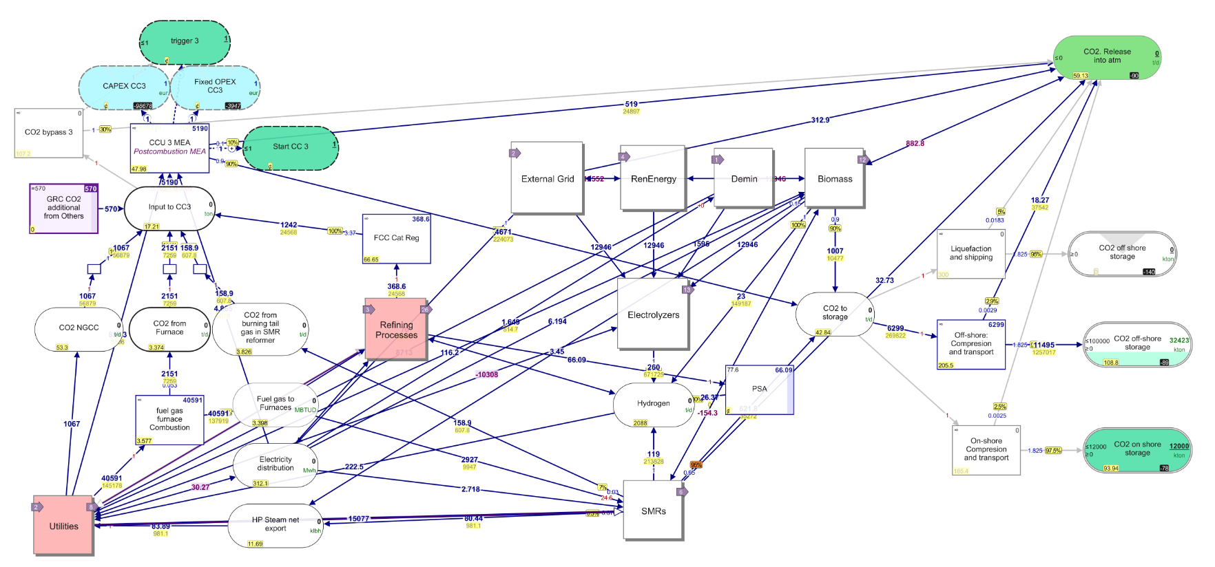
Figure 1. Linny-R Model. Screenshot of the main layer
  - Results and discussion
The impact of implementing the low-carbon H2 technologies on the energy and CO₂ balances of the two refineries is shown in Table 5. In both cases, the results show a significant reduction of CO₂ emissions in the short term (26% and 23% for HC and MC configurations, respectively) and they meet the target of CO₂ neutrality in 2050. The SMR with CC is the most cost-effective technology to produce hydrogen, with a production price between 1.0 and 1.5 €/kg lower than H₂ based on PEM electrolysis (using REN between 30-40 €/MWh). It reaches the same production price in the long-term horizon with a REN of 30 €/MWh and a forecasted incremental price of natural gas.

Hydrogen based on Biomass+ CC emerges as a viable option to achieve CO₂ emissions neutrality in the long term horizon, despite having a production cost that is 2-3 €/kg higher than the SMR-CC and REN-PEM electrolyzer alternatives. This is due to the significant advantage it provides as a "negative emissions process (NET)" when both biomass H₂ and the biomass electricity process are accompanied by CCS. Biomass processes alone (without CCS) contribute to a CO₂ reduction of 13% for both refinery configurations, with respect to the baseline. The results do not show any limitation concerning the availability of CO₂ underground reservoir. For the MC refinery, the onshore capacity (64 Mt CO₂) was enough until 2050 horizon. The HC Refinery will use 100 % onshore (12 Mt CO₂) and 32 % Colombian offshore of its CO₂ storage capacity by 2050. Similarly, the MC refinery will use 93 % of the on-shore of its CO₂ storage capacity by 2050.

Table 6. Energy and CO₂ impacts in oil refineries
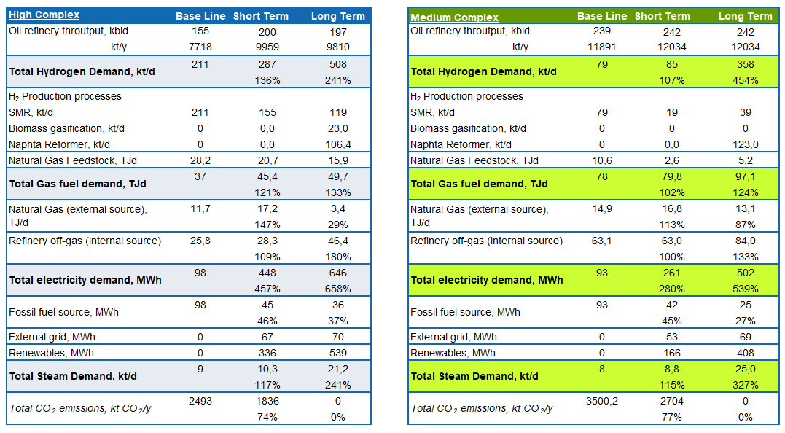
The impact of the refinery's level of complexity on the utilization of low-carbon hydrogen is evident in the short-term scenario. In the high-complexity (HC) refinery, a substantial reduction (26%) in CO₂ emissions was achieved, with 36% attributed to bio-electricity with CC used in the electrolyzers. In contrast, the medium-complexity (MC) refinery achieved a 17% reduction in CO₂ emissions, with 74% credited to bio-electricity with CC. For the long term, MC refineries gained an edge through the implementation of CO₂ capture from flue gas produced by fossil fuel combustion, resulting in an 85% reduction in total CO₂ emissions, in comparison to the 72% reduction achieved in the HC refinery configurations. The decarbonization technologies for the high-complexity refinery are oriented towards renewable energy (REN) and electrolyzers; whereas for the medium-complexity refinery, the optimization focuses on biomass + CC electricity and gasification to produce low-carbon hydrogen. In both cases, the Naphtha reformer + CC process was shown to be the less expensive way to produce low-carbon hydrogen, playing a significant role in the decarbonization pathways in the long-term horizon. Biomass-based H₂ with CC emerges as a viable option post-2030, despite having a higher hydrogen production cost. The benefits will likely far outweigh the negative impact on the Oil refinery's cash flow.

  - Conclusions
The combination of low-carbon hydrogen production and CO₂ capture technologies provides for both types of oil refineries a pathway to achieve the CO₂ reduction target committed by Ecopetrol in the short-term (75 %) and CO₂ neutrality in the long-term.
The level of complexity in oil refineries significantly impacts the decarbonization process, with the high-complexity refinery benefiting from low-carbon H₂ as feedstock for the processes and the medium-complexity refinery relying more on CO₂ capture in combination with hydrogen as an alternative fuel. However, the CO₂ emissions reduction is limited because of the avoiding flaring of surplus fuel gas generated as a consequence of the fuel shifting process.
However, a significant challenge lies in identifying suitable applications for surplus refinery fuel gas beyond its conventional use in combustion within boilers and furnaces will be necessary in future research.

References
Bots, P. (2022). Linny-r. In Version 1.0.15. https://sysmod.tbm.tudelft.nl/linny-r/docs/?15
Canova, W. (ecopetrol). (2021). Decarbonization Strategy of Ecopetrol Downstream sector. LARTC The Latin American Refining Technology Conference, 18.
IDEAM, Fundación Natura, PNUD, MADS, DNP, C. (2022). Informe del inventario nacional de gases efecto invernadero 1990-2018 y carbono negro 2010-2018 de Colombia . www.cambioclimatico.com
IEAGHG. (2017). IEAGHG Technical Review August 2017 Understanding the Cost of Retrofitting CO2 Capture in an Integrated Oil Refinery. August. https://ieaghg.org/docs/General_Docs/Reports/2017-TR8.pdf
IRENA. (2021). Reaching zero with renewables - Capturing Carbon. In /Technical-Papers/Capturing-Carbon.
Kaiser, M. J. (2017). A review of refinery complexity applications. Petroleum Science, 14(1), 167–194. https://doi.org/10.1007/s12182-016-0137-y
Khoo, H. H., & Tan, R. B. H. (2006). Life cycle investigation of CO2 recovery and sequestration. Environmental Science and Technology, 40(12), 4016–4024. https://doi.org/10.1021/es051882a
Knoope, M. M. J., Ramírez, A., & Faaij, A. P. C. (2015). Investing in CO2 transport infrastructure under uncertainty: A comparison between ships and pipelines. International Journal of Greenhouse Gas Control, 41, 174–193. https://doi.org/10.1016/j.ijggc.2015.07.013
Meerman, J. C., Hamborg, E. S., van Keulen, T., Ramírez, A., Turkenburg, W. C., & Faaij, A. P. C. (2012). Techno-economic assessment of CO2 capture at steam methane reforming facilities using commercially available technology. International Journal of Greenhouse Gas Control, 9, 160–171. https://doi.org/10.1016/j.ijggc.2012.02.018
Oliveira, C., & Schure, K. M. (2020). Decarbonisation options for the Dutch refinery sector. Dec.
SIGEA. (2019). Ecopetrol Emissions report.
Unidad de Planeación Minero Energética (UPME). (2019). Documento de cálculo del Factor de emisión de SIN 2018.
XM. (2020). Precio promedio y energía transada. http://www.xm.com.co/Paginas/Mercado-de-energia/preciopromedio-y-energia-transada.aspx.
Yoo, B. Y., Choi, D. K., Kim, H. J., Moon, Y. S., Na, H. S., & Lee, S. G. (2013). Development of CO2 terminal and CO2 carrier for future commercialized CCS market. International Journal of Greenhouse Gas Control, 12, 323–332. https://doi.org/10.1016/j.ijggc.2012.11.008
Younis, A., Suarez, L., Lap, T., & Edgar, Y. (2023). Exploring the spatiotemporal evolution of bioenergy with carbon capture and storage and decarbonization of oil refineries with a national energy system model of Colombia. 50(July). https://doi.org/10.1016/j.esr.2023.101232

